Commerce certification exam preparation

Content

Introduction 3

Commerce Basics 4

Base Commerce module 4

Base Stores 4

Stock service 5

Cart Service 5

Pickup In Store 6

How to Enable Pickup in store 6

Fraud Detection 6

Order Management 8

Order Management module 8

Order flow 8

Customer services 9

Warehouse Integration 9

Order process / Ordering Process 10

How to customize order process? 10

Payment 12

Payment providers 12

payment process ?? 13

payment commands 13

WCMS 14

What is the WCMS? 14

How to use it? 14

The model 14

Extending the WCMS 15

Extending WCMS using the CMS libraries 16

CMS components 16

CMS Restrictions 16

Advanced Personalization 17

BTG 17

Customer Segments 17

Evaluation context 18

Output Actions, 19

BTG cockpit 19

Vouchers and Promotions 20

Vouchers 20

Promotions 21

Commerceservices and commercefacades 22

Commercefacades 22

DTO 23

Converters 23

Commerceservices 24

Data Model 24

Events 24

Business Process 24

WCMS 25

Search And Navigation 25

solrfacetsearch Extension 25

Search & Navigation 26

Omni Commerce Connect 26

Supported operations 27

Context resources 28

Catalogs 28

Product 28

Cart 28

Order 29

Catalog 29

ProductCatalog 29

ContentCatalog 29

Barcode 30

Deeplinks ?? 30

DeeplinkUrlModel 31

DeeplinkUrlRuleModel 31

GenericDeeplinkUrlServlet 31

Pitfalls 32

# Introduction

Topics based on this website

<https://wiki.hybris.com/display/cert/Commerce+Developer+Certification+Exam+Guide>

# Commerce Basics

The Base Commerce module, Base Stores, Carts and the Stock service

<https://wiki.hybris.com/display/release5/basecommerce+Extension+-+Technical+Guide>

## Base Commerce module

**basecommerce** extension provides a set of multi-purpose services used in the hybris Commerce Suite. Most included services relate to the

[Order Management Module](https://wiki.hybris.com/display/release5/Order+Management+Module):

Customer Services:

Order Cancel Service

Return Service

Refund Service

Order History and Order Versioning

Order Splitting

Warehouse Integration

Replenishment and Order Scheduling

Store Locator

Stock Service

The hybris B2B Commerce Module adds business-to-business functionality to the hybris Commerce Suite. It enables you to integrate multiple channels, business models, and markets on a single platform. Thanks to the hybris B2B Commerce Module you are able to offer a retail-like shopping experience to your business customers, with integrated order process handling. Various permission settings enable you to efficiently and securely process your sales. You can integrate various products, multiple supplier catalogs, inventory, contracts, customer information, content, and orders onto a single solution.

## Base Stores

Specifies:

* locations of stores
* product catalog
* currencies
* website inside of hybris
* warehouse
* delivery countries
* payment provider
* pickup-in-store
* tax group
* distance calculation (km or miles)
* default language
* default currency

## Stock service

Used s:

* Product Stock Level Information
  + possible to update, access and display product stock level information
  + check status per warehouse /store
  + prevent or allow overselling
  + keeps track of inventory without life data from warehouse
* Product Availability Information
  + Manage and display availability
  + Offers strategies to calculate best availability over multiple warehouses
  + Localized messages for front end usage

Stock Service is a part of the **basecommerce** extension. It offers functionality to manage and query product stock level and product availability information, aggregated or for a specific warehouse. It also comes with strategies for splitting orders into different consignments depending on a product availability. To achieve this, Stock Service uses other parts of the hybris Commerce Suite, for example [Warehouse Integration](https://wiki.hybris.com/display/release5/Warehouse+Integration) and [Order Splitting](https://wiki.hybris.com/display/release5/Order+Splitting).

<https://wiki.hybris.com/display/release5/Stock+Service>

https://wiki.hybris.com/display/release5/Stock+Service+-+Technical+Description

## Cart Service

<https://wiki.hybris.com/display/DEVPORT/Cart+Service>

https://wiki.hybris.com/display/acc/Commerce+Cart+Service

**Cart Service** provides a set a features that support managing carts and the items in a cart. Using standard REST calls, it is possible to create, read, update, and delete the items and their quantities within a cart.

The Cart Service is used to manage the cart and the items within the cart. If a cart does not exist, it is automatically created when the shopper adds an item to the cart. If the cart does exist, the items within the cart can be added and the quantity can be modified (either overwritten or incremented). The items in the cart are also automatically removed if the quantity happens to be 0 (zero).

## Pickup In Store

<https://wiki.hybris.com/display/accdoc/Pickup+In+Store+in+the+hybris+Commerce+Accelerator>

hybris Commerce Accelerator for B2C supports a complete end-to-end Buy Online Pickup in Store (BOPiS) Check stock availability in nearby pickup locations.

Supports following actions:

* Add items to cart for pick up at proposed locations that have available stock along with items to be shipped.
* Consolidate order entries for multiple pickup locations in to a single pickup location.
* Pay online, collect order in store.
* View the order history and receive email notifications when the items are available to be picked up.

### How to Enable Pickup in store

* Set PickupInStoreMode on the BaseStore to BUY_AND_COLLECT
* Add one or more PointsOfService of the type STORE.
* For each PointOfService that offers the Pickup In Store Service, link a Warehouse.
* Assign the StockLevel to each PointOfService Warehouse.

## Fraud Detection

<https://wiki.hybris.com/display/release5/Fraud+Detection>

part of basecommerce extension

A standard provider implementation which checks for a number of symptoms without the need for an external system is also provided. This provider should be used in combination with a third party service provider as a first level check in order to reduce the number of paid requests to the third party provider. Of course it may be extended by custom symptoms.

Is there a out-of-the-box Fraud Service implementation?

Yes

Are there multiple symptoms supported?

Yes

Can it interact with external Fraud Service provider?

Yes

Fraud service evaluates defines symptoms and return a weighted value. The value is based on sum of all weighted values. The caller is responsible to flag a order a fraudulent.

Who flags an order as fraudulent?

* Fraud Service
* Order Process
* Call of Fraud Service
* platform

# Order Management

Order Management, Order flow, Customer services, Warehouse Integration

## Order Management module

The hybris Order Management Module is a generic business layer service with the following use cases: Authorize, capture, partial capture, cancel, follow on refund, and standalone refund.

The module provides:

* Order flow control
* Order versioning
* API for custom build services and strategies
* Replenish Order option

Benefits of the Order Management Module

* Customer experiences that are transferable from one channel to another
* Customer can research in one channel, buy products in another channel and check the status of the orders in yet another
* Centralized hub for processing and controlling all orders in an organization
* Provides an aggregated view of all orders placed by customers irrespective of channel
* Centralized hub for integration with other parties such as ERP, CRM, Warehouse Systems, IVR (Interactive Voice Response) Systems, Phone and other offline order systems
* Return management across channels (e.g. buy online, return in store)

## Order flow

Uses the process engine framework to run define process steps and validate possible next steps

Fulfillment process

checkOrder - order verification

checkAuthorizeOrderPayment & reserveAmount - payment

fraudCheck - fraud checking

maybe - orderManualChecked

notifyCustomer

maybe - splitOrder

sendOrderPlacedNotification

takePayment

modify order process/flow

change to process definition (XML file)

add bean definition to spring config (name of bean is used in process definition)

## Customer services

<https://wiki.hybris.com/display/release5/Customer+Services>

The customer services enhance Order Management Module ability to handle several scenarios that may occur during communication between shops, retailers and their customers. These services are implemented as a part of **basecommerce** extension.

For example, basecommerce extension provides functionality to allow cancellation of orders. Another case may be when the customer is entitled for a refund. Retailers may define own rules in such situation. **Return service**, in turn, is designed to support the process of returning the goods back from the customer to the seller.

## Warehouse Integration

<https://wiki.hybris.com/display/release5/Warehouse+Integration>

The Warehouse Integration interface supports communication between a warehouse and the hybris Commerce Suite during the Order Management process.

Warehouse Integration consists of two interfaces through which:   
 one in – one out

* Other systems like Warehouses can query the hybris Platform for orders.
* hybris Platform can send information to the Warehouse.

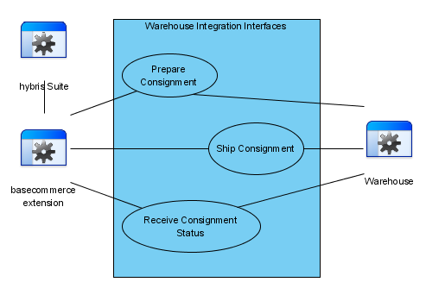

**Warehouse Integration is a simple reference interface**

public interface Process2WarehouseAdapter

public interface Warehouse2ProcessAdapter

## Order process / Ordering Process

The hybris Commerce Suite has a built-in ordering process that automatically handles calculation of prices, taxes, and discounts for orders. The focus lies on the creation, calculation, recalculation, and lifetime of the carts and orders.

<https://wiki.hybris.com/display/release5/Ordering+Process>

### How to customize order process?

<https://wiki.hybris.com/display/tr52/Customizing+the+order+fulfillment+process>

preferred - create a new extension based on yacceleratorfulfilmentprocess

change existing order-process

* define a ProcessDefinitionResource in a Spring config

<bean id=*"orderProcessDefinitionResource"* class=*"de.hybris.platform.processengine.definition.ProcessDefinitionResource"* >

<property name=*"resource"* value=*"classpath:/yacceleratorfulfilmentprocess/process/order-process.xml"*/>

</bean>

* bean definition for each process action
* XML based file with process definition

<?xml version="1.0" encoding="utf-8"?>

<process xmlns="http://www.hybris.de/xsd/processdefinition" start="checkOrder" name="order-process" processClass="de.hybris.platform.orderprocessing.model.OrderProcessModel">

<action id="checkOrder" bean="checkOrderAction">

<transition name="OK" to="checkAuthorizeOrderPayment"/>

<transition name="NOK" to="error"/>

</action>

……

# Payment

Payment providers and the payment process

[**https://wiki.hybris.com/display/release5/Payment+Module+-+Business+Guide**](https://wiki.hybris.com/display/release5/Payment+Module+-+Business+Guide)

The hybris Payment Module enables you to use the payment service provider adapters, for example, the cybersource extension, in order to integrate payment gateways into the hybris Commerce Suite.

## Payment providers

The hybris Payment Module is ready to coordinate the flow of transactions among a complex network of financial institutions and processors.

The hybris Payment Module enables you to use the services of the external payment service providers in order to handle the electronic payments. The module can support you by its flexible approach to the multi-channel on-line payment methods depending on the available payment service adapters.

**Payment module helps to connect to PSP-specific payment adapter**

Cybersource is supported out-of-the-box, but can be extended to work with others as well.

Cybersource extension

Use the hybris Payment Module to:

* Increase revenue by providing customers with multiple payment options
* Eliminate complexity and reduce cost by connecting to major PSP
* Enable immediate authorization through automated payment validation
* Centralize management of payment processing for one or more sales channels
* Ensure a secure link between you, your customer, and your credit card processor

Paymemt module supports the following tasks

* Embedded Credit Card Payment Processing
* Embedded Debit Card Payments Processing
* Payment Authorization
* Multiple Credit Card Payment
* Voiding Transaction
* Refund

## payment process ??

## payment commands

<https://wiki.hybris.com/display/release5/Payment+Integration+Overview#PaymentIntegrationOverview-AuthorizationCommand>

|  |  |
| --- | --- |
| AuthorizationCommand | Command for handling card authorizations. Card authorization is the **first step** in card payment process. **Authorized amount** of money remains "locked" on card's account until it is captured or authorization is reversed (cancelled) or authorization is expired |
| CaptureCommand | Capturing an authorization means the authorized amount of money is **actually transferred from the card holder account to the merchant account**. Capture operation **requires** a previous successful **authorization** that has not yet expired. |
| PartialCapture | handling partial card authorization captures |
| VoidCommand | voiding capture or credit. Refund means to cancel a capture or credit request. Transaction can be voided only if payment service provider has not already submitted the capture or credit card to processor. |
| FollowOnRefundCommand | Follow-on refund means to return back money to customer account associated with order or previous transaction. It is contrary to stand-alone refund {@link StandaloneRefundCommand} |
| StandaloneRefundCommand | Stand-alone refund means to return back money to customer account not associated with any order or previous transactions. Just passes money from one account to another contrary to {@link FollowOnRefundCommand} |

# WCMS

## What is the WCMS?

* The hybris WCMS Module allows end users to manage website pages, providing them with an intuitive, graphical way of data presentation and management.
* Supports multiple Storefronts from inside of the same web app
* Can handle localization for content elements

## How to use it?

* hybris WCMS Cockpit
* /cmscockpit default contextpath
* WCMS Cockpit provides a simple way for cockpit end users
* Supports three perspectives
  + Page View Perspective -  advanced management of website pages
  + Life Edit Perspective - simplified management of website pages including preview
  + Customer Segments Perspective - Describes the advanced personalization functionality

## The model

In this scenario, there are two PageTemplates: Default PageTemplate and Brand PageTemplate. Each of them defines some ContentSlots, where CMS Components can be placed in. The first PageTemplate defines four ContentSlots (e.g. header, footer, navigation and main), the second one defines only two ContentSlots (e.g. navigation and main).

Also, on the PageTemplates there are already some Components assigned to the ContentSlots, for example the Default PageTemplate already contains an image in the header and a text element in the footer; the Brand PageTemplate contains a LinkList in the navigation ContentSlot.

Next there are three Pages, two of them use the Default PageTemplate as PageTemplate and the third one is based upon the Brand PageTemplate. The pages already contain the Components which are defined on the PageTemplate, so an editor does not need to define the image in the header ContentSlot again and so on. Also changes in the Components on a PageTemplate are automatically applied to all pages which use this template.

Finally we have a list of Components which can be placed on PageTemplates or Pages.

So page editing or creation happens in the following way: The CMS defines a set of different PageTemplates and Components, an editor chooses for a PageTemplate for each page and adds his contents by placing Components in ContentSlots. Components can also be placed on ContentSlots of PageTemplates, so every new page instance will automatically have those Components.

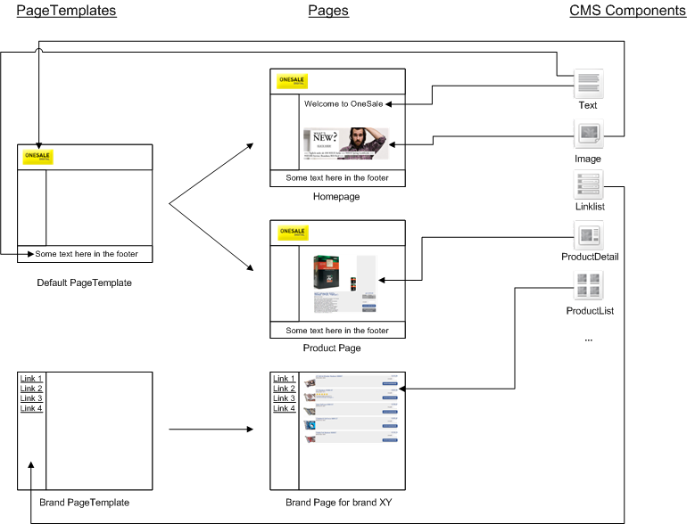

## Extending the WCMS

* WCMS Cockpit is technically provided by the CMSCockpit extension
* website constructed using the CMS2 extension

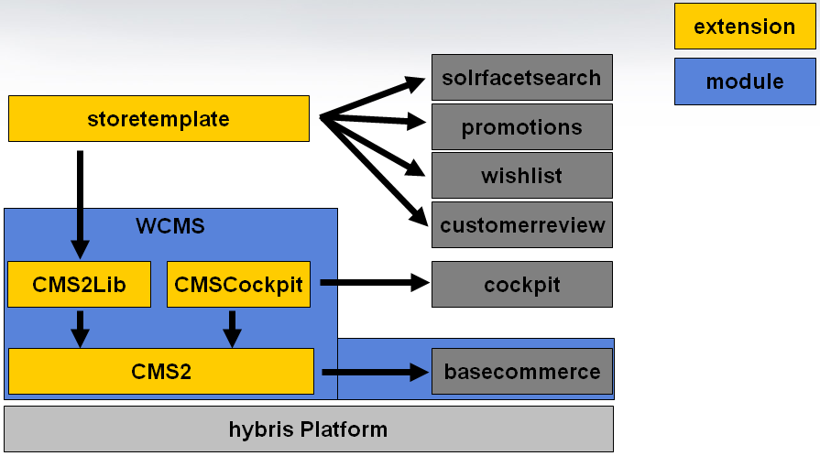

## Extending WCMS using the CMS libraries

* extended components are included in the CMS2Lib extension

## CMS components

All components need to be extended from CMSItem or a subtype

Can be synchronized between catalog versions

Is it required to assign a CMS component to a catalog?

Yes

<itemtype code="CMSItem" jaloclass="de.hybris.platform.cms2.jalo.contents.CMSItem" extends="GenericItem" autocreate="true"

generate="true" abstract="true">

<custom-properties>

<property name="catalogItemType">

<value>java.lang.Boolean.TRUE</value>

</property>

<property name="catalogVersionAttributeQualifier">

<value>"catalogVersion"</value>

</property>

<property name="uniqueKeyAttributeQualifier">

<value>"uid"</value>

</property>

</custom-properties>

<attributes>

<attribute qualifier="uid" generate="true" autocreate="true" type="java.lang.String">

<persistence type="property" />

<modifiers optional="false" unique="true" />

</attribute>

<attribute qualifier="name" generate="true" autocreate="true" type="java.lang.String">

<persistence type="property" />

</attribute>

<attribute qualifier="catalogVersion" type="CatalogVersion">

<modifiers optional="false" unique="true" />

<persistence type="property" />

</attribute>

</attributes>

</itemtype>

## CMS Restrictions

# Advanced Personalization

<https://wiki.hybris.com/display/release5/Advanced+Personalization+Module>

With the hybris AP (**AP - Advanced Personalization**) module you can easily set up rules - depending on several criteria - which allows you to segment your customers into different groups. In a second step this segmentation can be used for different actions, like personalizing the content which will be shown to your customers. You can use several AP elements in order to accomplish this goal.

## BTG

The hybris Advanced Personalization Module lets you easily set up the rules—depending on several criteria—allowing you to segment your customers into different groups. In a second step this segmentation can be used for different actions, like personalizing the content which will be shown to your customers.

Technically this functionality is provided by the **btg** and **btgcockpit** extensions, while from the user perspective it relies on the cockpit framework to provide typical WCMS Cockpit interface. It means that Advanced Personalization Module requires WCMS Module due to technical dependency and licensing.

## Customer Segments

The customer segment is an object which supports the Advanced Personalization feature by enabling the segmentation of customers into the groups based on the definable Customer Segment Rules. In further part of this document you find explanation of the concept of segments for Advanced Personalization, and see how users are put into segments and what it means to belong to a segment.

The customer segment consists of rules that set the conditions for the users or groups of users and actions triggered after all the rules are successfully fulfilled.

If one rule doesn’t apply, the validation stops

Output action is triggered when all rules are fulfilled

Customer segment has information about

Catalog version

Default result

Sites where segment can be used or not used

From & until

isActive

Rules

Example

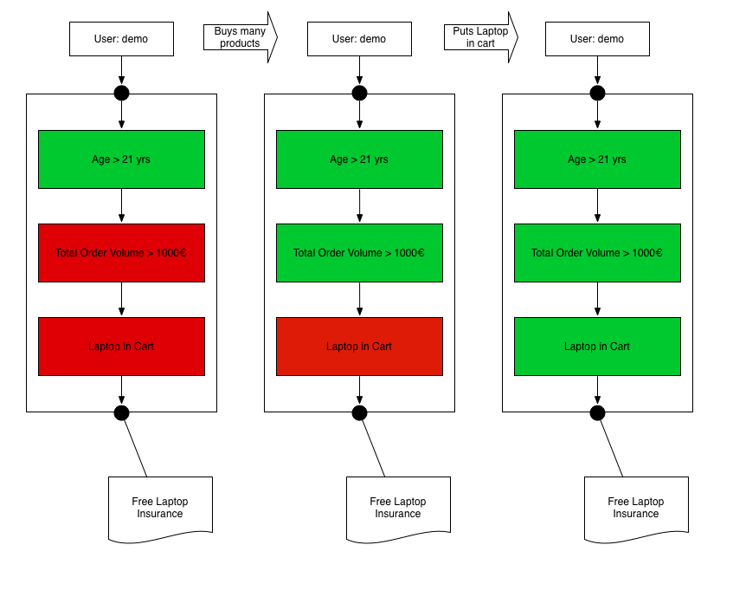

## Evaluation context

|  |  |
| --- | --- |
| BTGEvaluationMethod.FULL, BTGEvaluationMethod.OPTIMIZED | A segment can be considered not fulfilled if one of its conditions evaluates to false. That is because all conditions and rules follow the logical conjunction (and) logic together. **Usually it is acceptable to stop evaluating when the first condition has evaluated to false, because the whole segment can no longer be fulfilled.** This is called the **optimized** mode. On the other hand for testing purposes you might want to have all the rules and conditions evaluated, no matter if one of them evaluates to false. This is called the **full** mode.  Default setting is: optimized |

## Output Actions,

<https://wiki.hybris.com/display/release5/Output+Actions+Overview#OutputActionsOverview-ExtendingAvailableOutputActions>

The Output Actions provide you with the means of assigning your customers into personalized groups depending on their on-line behavior and other definable criteria. You can use available actions to assign users to groups or to decide what type of content is shown to them. Additionally, you can also create your own actions.

StandardAction output of BTG extension are subclasses of **BTGOutputActionDefinition**

Catalog aware item to fit the staging capability of the segment

Can assign a user to a group when rules fulfilled

## BTG cockpit

part of WCMS cockpit

can specify and enable/disable customer specific rules/actions

* customer segment rule
  + order rules
  + cart rules
  + customer rules
  + website rules
* define output action
  + add user to usergroup
  + assign user to root business unit
  + show or hide wcms item

# Vouchers and Promotions

Vouchers, promotions, single code vouchers, multi code vouchers, restrictions, how to use,

## Vouchers

<https://wiki.hybris.com/display/release5/Voucher+Module+-+End+User+Guide>

The hybris **voucher** extension enables you to create and manage vouchers redeemable by your customers.

Typically you handle voucher and voucher restriction in the hybris Management Console(hMC).

Offers option for

* fixed discount value (e.g. 10 off)
* percentual discount (e.g. 20% off)

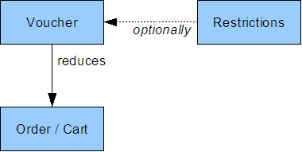

to a voucher can restrictions apply on top to conditions, before it applies

resctrictions can be apply to

* user
* products
* orders
* dates

two kinds of voucher,

* serial voucher (one time usage)
* promotion voucher (multiple time usage per store and/or customer)

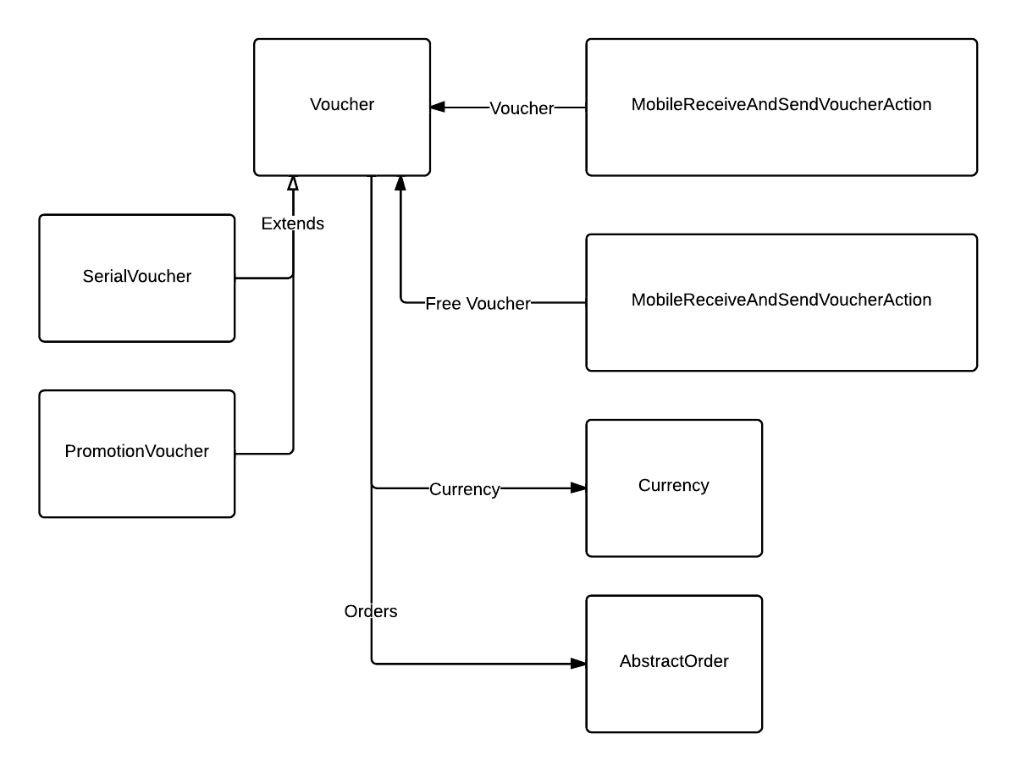

## Promotions

<https://wiki.hybris.com/display/release5/Promotion+Module>

<https://wiki.hybris.com/display/release5/Key+Concepts+of+Promotions>

The hybris Promotion module enables the creation and management of customer sales promotions. Customer sales promotions are a means for retailers to affect customer shopping behavior, often to increase the average order value (AOV), by offering incentives.

The promotions extension consists of a code component that may be used to implement customer sales promotion functionality within web sites and a hybris Management Console (hMC) component for creating and managing promotion data.

The promotions extension uses the BaseStore type, which is a part of the basecommerce extension,

A promotion defines a single customer sales promotion. Promotions contain a rule set that defines the conditions for activation and a set of operations that define the effect of the promotion when activated.

The following classes of promotion are included with the promotions extension:

* **Product level promotions** are activated based upon the products within the line items of a shopping cart or order.
* **Order level promotions** are activated based upon shopping cart or order attributes.

Promotions are create to hMC

Newly created promotion are initially in disabled mode

Possible restrictions

* Date Restrictions
* Product Restrictions
* User and Usergroup Restrictions
* Order Restrictions

It is useful to know that a promotion has been partially activated so that this may be communicated to customers on a website. E.g. a message such as "Add another snowboard to your basket and receive 50% off your order" could be displayed.

Description and Messages can be parameterized

**promotion group** is a set of promotions that may be selected for use on a website

A promotion **must** always be associated with a promotion group.

# Commerceservices and commercefacades

Some of the detail of working with these APIs, what the scope of what they do is.

## Commercefacades

<https://wiki.hybris.com/display/acc/Commerce+Facades>

A facade layer is required as part of basecommerce to provide a flattened, simplified view of the data model. This layer comprises of

* *Facades*
* *Data Objects*
* *Converters*
* provides easier rendering of the data model to the front end, as well as Web Service enablement

Please see [Using Facades and Data Objects - Best Practice](https://wiki.hybris.com/display/release4/Using+Facades+and+DTOs+-+Best+Practice) for guidelines.

|  |  |
| --- | --- |
| [Product Facade](https://wiki.hybris.com/display/acc/Product+Facade) | Access Product information from the catalog as well as perform actions on Products. |
| [Search Facade](https://wiki.hybris.com/display/acc/Search+Facade) | Search for Products and refine the search by navigating facets and/or free text search. |
| [Cart Facade](https://wiki.hybris.com/display/acc/Cart+Facade) | Build up your order, add deliver and payment information and place the order. |
| [Order Facade](https://wiki.hybris.com/display/acc/Order+Facade) | Access orders, cancel etc. |
| [User Facade](https://wiki.hybris.com/display/acc/User+Facade) | User account related activities |
| [Promotions Facade](https://wiki.hybris.com/display/acc/Promotions+Facade) | Access Promotions |
| [Store Session Facade](https://wiki.hybris.com/display/acc/Store+Session+Facade) | Mostly read-only stuff about the current site, setters will implicitly be called in Web service and Web Servlet filters |
| [Store Locator Facade](https://wiki.hybris.com/display/acc/Store+Locator+Facade) | Typical commerce store locator functionality |

### DTO

It is a POJO

Data Transfer Objects(DTOs) are objects created to only contain values and have no business logic except for getter and setter methods. Using DTOs, you can combine hybris items for example

### Converters

Reusability

In fact there is already a predefined interface, the Converter interface   
 Converter<Source, Target>

Define as bean in spring.xml

AbstractConverter provide base implementation for

* Convert
* Populate

## Commerceservices

<https://wiki.hybris.com/display/acc/Commerce+Services>

| **Service Name** | **Description** |
| --- | --- |
| [Contact Service](https://wiki.hybris.com/display/acc/Contact+Service) | Handles contact with the customer |
| [Commerce Search Service](https://wiki.hybris.com/display/acc/Commerce+Search+Service) | Handles Apache Solr search & navigation requests |
| [Commerce Cart Service](https://wiki.hybris.com/display/acc/Commerce+Cart+Service) | Provides cart management functionality |
| [Commerce Delivery Service](https://wiki.hybris.com/display/acc/Commerce+Delivery+Service) | Handles delivery capabilities |
| [Commerce Checkout Service](https://wiki.hybris.com/display/acc/Commerce+Checkout+Service) | Hadles checkout functionality |
| [Commerce Customer Account Service](https://wiki.hybris.com/display/acc/Commerce+Customer+Account+Service) | Handles customer account management capabilities |
| [Commerce Inventory Service](https://wiki.hybris.com/display/acc/Commerce+Inventory+Service) | Handles inventory functionality |
| [Commerce Price Service](https://wiki.hybris.com/display/acc/Commerce+Price+Service) | Extends Out of the box price service by adding further price functionality for b2c |
| [Store Lookup Service](https://wiki.hybris.com/display/acc/Store+Lookup+Service) | Handles store location functionality |

### Data Model

Commerce Services will also extend the existing hybris data model.

### Events

Commerce Services will raise a number of events, this will be the typical integration point for a spring integration service activator that listens for these events. The service activator consumer will often start a business process.

### Business Process

Commerce Services will provide some business process that will activate for a number of [events](https://wiki.hybris.com/display/acc/Commerce+Services+Events) in the system.

All the following events will have a spring integration service activator endpoint that will create new processes with the following [Storefront Business Process Model](https://wiki.hybris.com/display/acc/Storefront+Business+Process+Model)

* onRegister
* forgottenPassword

We will introduce a new generic set of business process steps for handling the generation and sending of emails.

### WCMS

We will customise the WCMS to support editing of content slots inside emails.

# Search And Navigation

<https://wiki.hybris.com/pages/viewpage.action?pageId=141793692>

Facet searching and Navigation

The hybris Search & Navigation Module supports efficient search and navigation by providing the solrfacetsearch extension in cooperation with the Solr search server. It provides:

* Commodity features for Search & Navigation
* Fully integrated Solr facet search
* Tools to configure and automate the indexing of data for search.
* Natural Language Search
* Sorting and Ranking
* Synonyms and Stop Words
* Spell Checking
* and more

Facet search, also referred to as faceted search or faceted filtering, is a navigation technique for accessing a collection of available information by narrowing down long lists of objects to a manageable size

* Keyword redirect – e.g. redirect for “basket” to the cart page, “shipping” to shipping information page
* Synonym mapping 🡪 e.g. sneaker to trainer, if only trainer is used in description
* SpellChecker – did you mean “???”
* Keyword auto completion / suggestions

Configuration of Solr at runtime

Requires ysolr.jar (version 4.x)/hybriscomponents.jar (version 5.x) to put in Solr lib fodler and change Solr config.

Allows solr config at runtime, also for standalone installations

## solrfacetsearch Extension

The hybris **solrfacetsearch** extension provides faceted search and navigation functionality based on the Apache Solr server. It enables you to do a faceted (also called dimensional) search over hybris items such as products and WCMS contents.

Features

* **Natural Language Search**: Effective full text search detecting, for example plural forms and compound words to provide relevant search results.
* **Configurable Faceting**: Administrators can add attributes from the data model, the classification system or even 3rd party systems to the search index and the facet navigation.
* **Sorting and Ranking**: Allows users to sort the search results by relevancy, price, rating or other criteria.
* **Multi-select of Facet Values**: When refining the search results, users can select multiple values for a multi-valued facet. Customers can refine their search by selecting multiple dimension values, for example size S and L, and XL.
* **Searchandising with Keyword Redirects**: Retailers can manage the content for certain products to maximize conversions and up-/cross-sell opportunities by redirecting specific keywords to carefully merchandised landing pages.
* **Synonyms and Stop Words**: Business users can easily configure synonyms and stop words without requiring IT or back-end development work to reflect real-world shopper behavior on an ongoing basis.
* **Autocomplete Suggestions**: Simplifies and speeds up navigating the site, enabling shoppers to explore the content of a website with fewer mouse clicks.
* **Spell Checking**: Spell checking enables retailers to detect and correct typos and to deliver relevant results even if the shopper misspells a keyword. It improves the search experience and helps shoppers reach desired search results with minimized effort.
* **Extensible API**: Allows easily extending the S&N functionality to leverage advanced features of the underlying SOLR search system.

## Search & Navigation

https://wiki.hybris.com/pages/viewpage.action?pageId=141793709

# Omni Commerce Connect

<https://wiki.hybris.com/display/release5/Omni+Commerce+Connect+5.0>

Using the Commerce Web services

hybris Omni Commerce Connect (OCC) offers a broad set of commerce and data services which leverage the complete hybris Commerce Suite functionality anywhere in a client's application landscape. hybris OCC allows new or existing hybris customers to quickly commerce-enable new touch points and new channels without lengthy and costly IT cycles.

hybris OCC utilizes **RESTful**, commerce-driven web services. The web services are based on **Spring MVC 3** and are delivered as a template, making it easy for partners to customize and extend them. Both **XML and JSON** representations are supported, and conditional requests via ETags are supported too. All input to the web services is done via simple URL-encoded parameters in either the request URL or request body.

Our web services support the OAuth 2 protocol as well as Basic Authentication over HTTPS for ease of use and security.

With hybris Version 5 we have added exciting new methods and resources to Omni Commerce Connect to support the complete shopping journey for customers using mobile applications and other OCC-connected clients:

* Customers can now access their [Order History and Order Details](https://wiki.hybris.com/display/release5/Resource+Orders).
* New [Location Services](https://wiki.hybris.com/display/release5/Resource+Stores) help to find stores nearby.
* Search and Navigation supports [Keyword Autocompletion and Spell Checking](https://wiki.hybris.com/display/release5/Resource+Products).
* Users who forgot their password can now execute the [Password Reset Flow](https://wiki.hybris.com/display/release5/Resource+Customers).
* Product [Reviews](https://wiki.hybris.com/display/release5/Resource+Products) can be posted and retrieved.
* An extended [User Profile Management](https://wiki.hybris.com/display/release5/Resource+Customers) allows customers to update their payment information as well as personal details like their username and email address.
* [User Group](https://wiki.hybris.com/display/release5/Resource+Customergroup) information is exposed to enable content personalization.

In addition, Omni Commerce Connect now supports the [OAuth 2 authentication flow](https://wiki.hybris.com/display/release5/ycommercewebservices+Extension+-+Technical+Guide" \l "ycommercewebservicesExtension-TechnicalGuide-OAuth2.0ProtocolinCommerceWebServices).

Podcast about it

<https://wiki.hybris.com/display/media/Omni+Commerce+Connect+Introduction>

<https://wiki.hybris.com/display/media/Omni+Commerce+Connect+Live+Demo>

## Supported operations

<https://wiki.hybris.com/display/media/Omni+Commerce+Connect+Introduction>

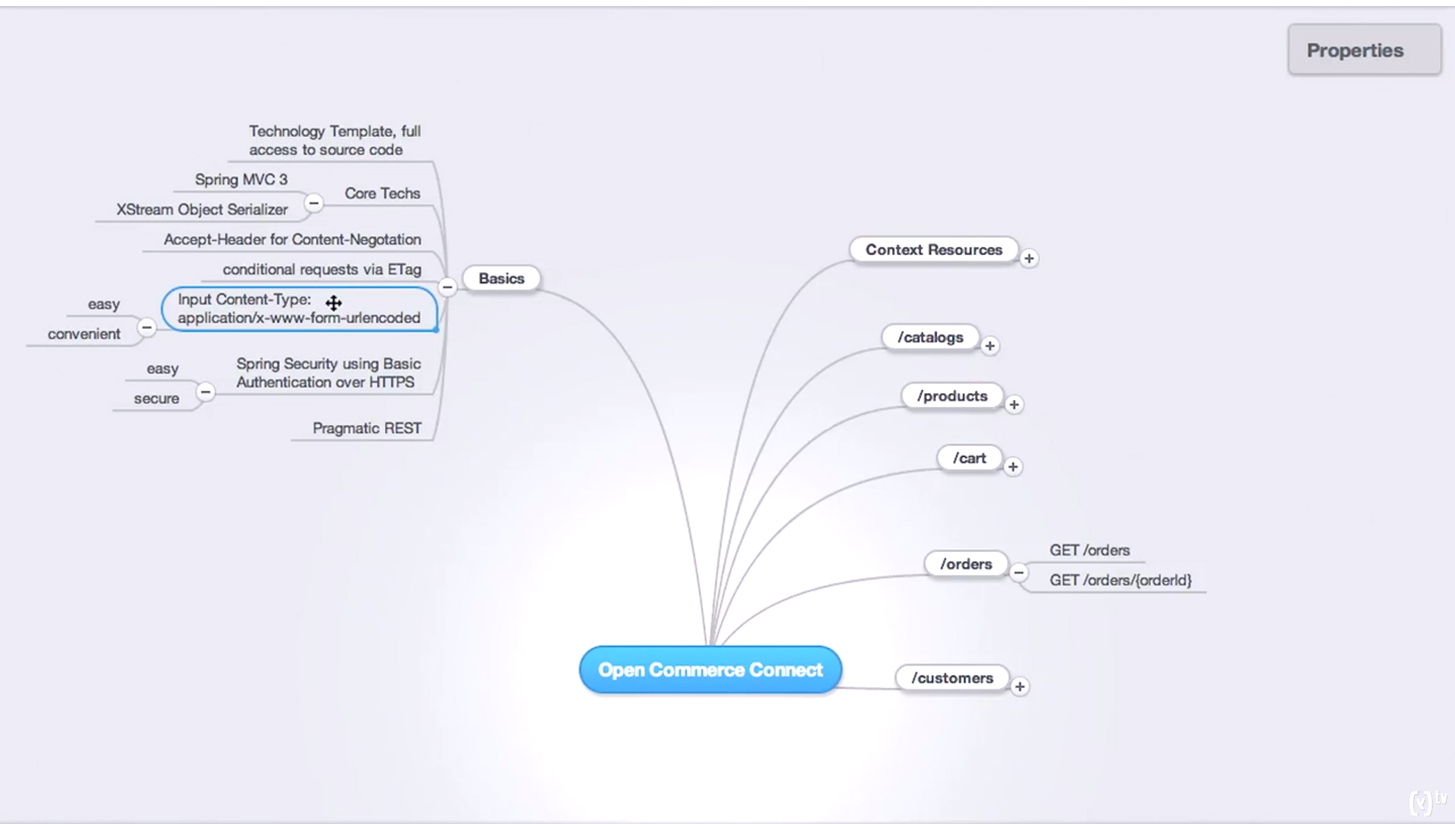

### Context resources

* + GET languages
  + GET titles
  + GET currencies
  + GET deliverycountries
  + GET cardtypes

### Catalogs

* + GET cataloges
  + GET cataloges/{id}
  + GET cataloges/{id}/{version}
  + GET cataloges/{id}/{version}/categories/{categoryId}

### Product

* + GET products
  + GET products/{code}
  + GET products/export/full
  + GET products/export/incremental

### Cart

* + GET cart
  + POST/PUT/DELETE /cart/entry
  + PUT /cart/address/delivery/{addressId}
  + DELETE /cart/address/delivery
  + GET /cart/deliverymodes
  + PUT /cart/deliverymodes/{deliveryModeId}
  + DELETE /cart/deliverymodes
  + POST cart/paymentinfo
  + PUT cart/paymentinfo/{paymentId}
  + POST cart/authorize
  + POST cart/placeorder

### Order

* + GET orders
  + GET orders/{orderId}

Omni Commerce Connect - Business Guide

https://wiki.hybris.com/display/release5/Omni+Commerce+Connect+-+Business+Guide

# Catalog

## ProductCatalog

Catalog item, defines in catalog-items.xml

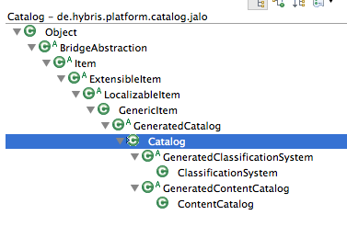

## ContentCatalog

Is a subtype of Catalog item, defines in cms2-items.xml

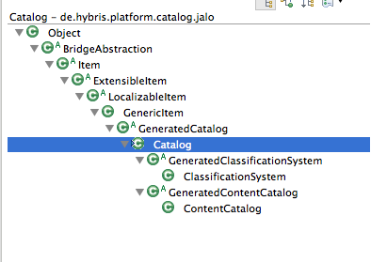

<itemtype code="ContentCatalog" jaloclass="de.hybris.platform.cms2.jalo.contents.ContentCatalog" extends="Catalog"

autocreate="true" generate="true">

</itemtype>

# Barcode

<https://wiki.hybris.com/display/pm/hybris+Mobile+Barcodes>

<https://wiki.hybris.com/display/release5/Generating+Barcodes>

The best option for customers on the go are QR Codes (QR stands for quick response). A QR Code is a two-dimensional bar code. Out of the box, the hybris Commerce Suite can generate QR Codes to products, categories and vouchers.

Hybris can generate barcodes for ?

* A specific product page, for example if the 2D barcode is in a print catalog
* A specific product category, for example in a catalog you put a special call to action to go to Special Offers
* A voucher of all the kinds supported in hybris

How to generate a barcode?

Go to hMC and then to

Products or Categories or Voucher

Go to Mobile tab

Generate a barcode and download

# Deeplinks ??

<https://wiki.hybris.com/display/release5/Deep+Linking+-+Technical+Guide>

Deep link URL feature is a part of the hybris basecommerce extension.

Can create short url’s for some context items and long description urls.

Based on information extracted from short URL with usage of a template in a **DeeplinkUrlRule**

Of which extension is Deeplinks part of?

Basecommerce extension

The basecommerce extension provides also a generic Servlet which can use short URL, translate it and redirect user to the destination URL.

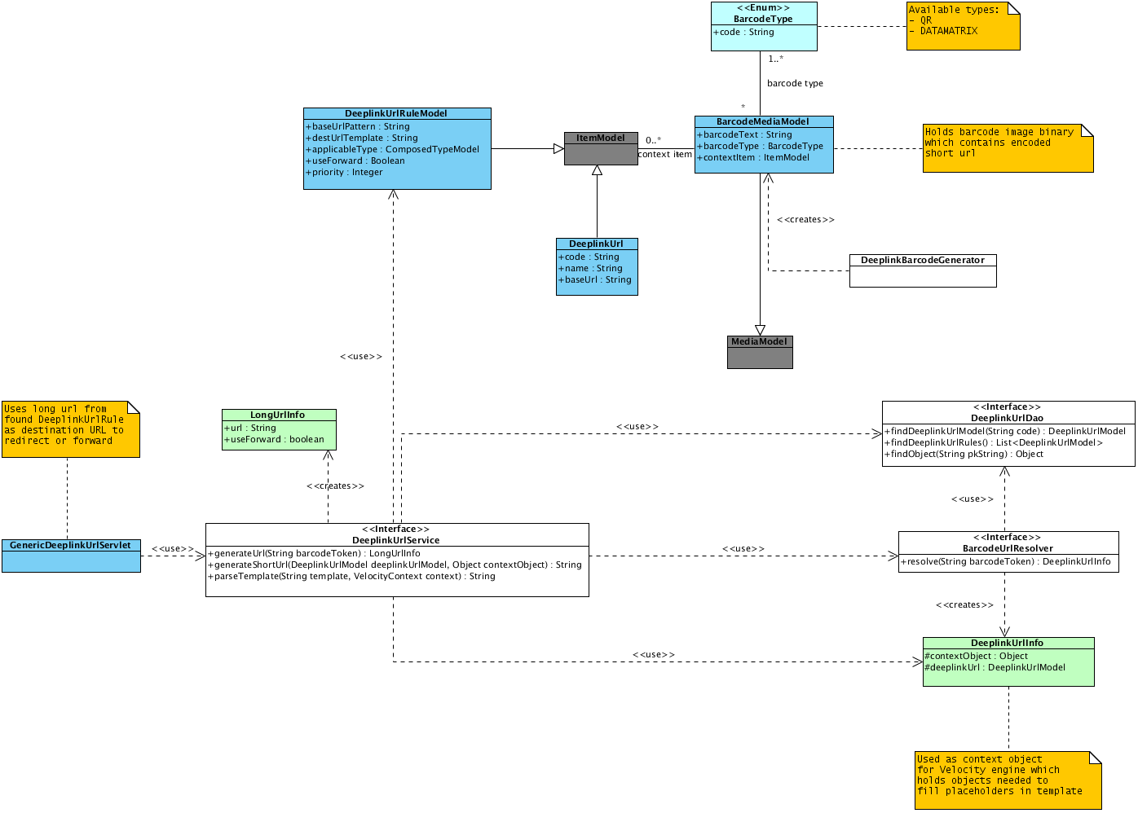

## DeeplinkUrlModel

Contains a code, name and BaseURL.

The BaseURL points to the Deeplink URL Servlet, e.g. <http://www.website.com/mobile/link>

## DeeplinkUrlRuleModel

technical mapping from the deep link URL string to the destination URL

value

baseUrl e.g. to find right website (example .*www\.website\.com.*

destUrl destination URL pattern, use context from applicableType

can contain/use variables of context object/item or the

deeplink URL itself

useForward to use forward, otherwise use redirect

## GenericDeeplinkUrlServlet

Deep link URL Servlet is used for getting short URL (for instance obtained from barcodes by mobile device), transforming it and next redirecting or forwarding to the destination URL.

# Pitfalls

Tricks and traps, good practice with live servers.

<https://wiki.hybris.com/display/release5/Project+Tips+and+Pitfalls+-+Best+Practices>

* Changing Default Passwords
* Appserver
  + Use the latest update of 64 bit Java 7
  + Set memory to XMS equals XMX **–Xms6G -Xmx6G**
* Adjusting Cache Size
  + In local.properties
  + regioncache.entityregion.size=100000  
    regioncache.querycacheregion.size=20000
* Protect Production System/Database from Initialization
  + system.unlocking.disabled=true
* hybris Price Accuracy
  + europe1.price.accuracy=hour
  + only required if use Europe1 price factory or extended this
* Reduce FlexibleSearch Statements Accuracy as Much as Possible
  + Add a timestamp or just date to a query to allow/prevent caching
* Optimizations for Cluster Setup
  + See <https://wiki.hybris.com/display/release5/Cluster+-+Technical+Guide#Cluster-TechnicalGuide-Cluster-Performanceoptimizations>
* Disabling Facelets Development Mode
  + Web.xml  
    <context-param>  
     <param-name>facelets.DEVELOPMENT</param-name>  
     <param-value>false</param-value>  
    </context-param>
* Server Side JSF State
  + Save jsf state at server side to reduce page size
  + <context-param>  
     <param-name>javax.faces.STATE_SAVING_METHOD</param-name>  
     <param-value>server</param-value>  
    </context-param>
* Page Compression
  + For smaller pages, is larger pages, can slow down at client side, needs to wait for full page to load
* Memory Analysis
* Backup/Migration Issues
  + Keep a freeze snapshot of the code you went live with in the repository
  + Design and test not only a *backup* strategy, but also a *restore* strategy
  + Export CSV filter for crucial data in the hybris Commerce Suite (ImpEx)
* Security Issues
  + Change default passwords
  + Change context path /hac, /hmc, …
  + SSL, VPN access
  + Access to admin from outside required?
* Tanuki Wrapper Configuration
  + Disable restart trigger for out of memory
  + #--to restart the server when facing OutOfMemories  
    # CAUTION: Before activating the feature below, please be sure that you are aware of the potential SECURITY RISKS for your application (see: PLA-10071, ACC-1591)  
      
    # wrapper.filter.trigger.1=java.lang.OutOfMemoryError  
    # wrapper.filter.action.1=RESTART